- We will be using menti.com for some in-class polls. Make sure you have a device on which you can go to www.menti.com.

- We will be going over this paper “Mitochondrial hydrogen peroxide positively regulates neuropeptide secretion during diet-induced activation of the oxidative stress response”. Please make sure you either have a copy of it on your device (available on Canvas) OR you have requested a physical copy from Dr. Matty.

Slide 3: Go to www.menti.com and enter the code 4196 3275
- What are three words you use to describe yourself?

- What is something you hope to get out of BIMM194?

Slide 4: Class learning objectives
- Identify peer-reviewed scientific research articles
- Summarize the major points of a research article using a quick skim or keyword approach
- Begin to evaluate components of a research article as interesting, applicable and/or justified
- Visualize yourself as a scientist

Slide 5: Human hello. Who did you meet? What did you talk about? If you got their email / contact, put it here!

Slide 7: What is a peer-reviewed research article?
Pop Science Article | Peer-reviewed primary literature

Slide 8: Somewhere in between:
- Perspectives/Commentaries:
- Previews / News&Views:
- Reviews:

Slide 9: Where to find peer-reviewed articles:

Slide 10: How familiar are you with reading scientific literature?
Ensure that you have access to “Mitochondrial hydrogen peroxide positively regulates neuropeptide secretion during diet-induced activation of the oxidative stress response”
- Before even beginning, take a moment to find words in the title that you recognize / think of as important.

Slide 11: Jump in for a quick skim
In what order are the main sections of this article?

Slide 12: Find the main points and use keywords: Spend 5 minutes alone and 5 minutes with your group to discuss your section’s takeaways, importance, and unexpected features.

Group 1: Abstract

Group 2: Figure layout (Figures #1-4)

Group 3: Introduction

Group 4: Results sub-headings

Group 5: Discussion key phrases

Slide 15-17: Ask questions before/while reading:
- What journal is this?

- Who are the authors?

- Is this interesting to me?

- How are the data presented?

- When/why would someone want to read this paper?

Slide 18: How do you feel now?
- Go to www.menti.com and use the code 7113 2835 to answer the question “what aspect of scientific literature are you most unsure/nervous about?”

Slide 19: Figure it out
- How to approach reading figures:
  - Read the title
  - Read the corresponding results section
  - Read additional references to the figure (Command+F to find it throughout)

Slide 20: Figure 4A - B
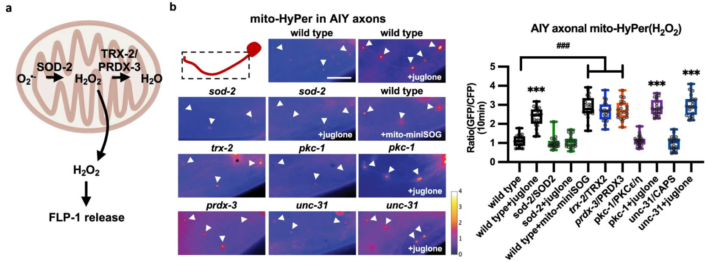

What is this figure showing?

Slide 21: Read the legend
- Acronyms, statistics, color-coding, details of the experimental set-up:
- Figure 4A-B legend:
a Schematic representation of the generation of mitochondrial hydrogen peroxide (mtH₂O₂) by dismutation of superoxide (O₂⁻) by mitochondrial SOD-2/superoxide dismutase, and its consumption by the mitochondrial TRX-2/thioredoxin PRDX-3/peroxiredoxin system, which converts mtH₂O₂ to H₂O. b Representative images and quantification of fluorescence in AIY axons of the indicated transgenic animals expressing mitochondrial-targeted HyPer (mito-HyPer) driven by ttx-3 promoter. Arrowheads indicate mitochondrial fluorescence in AIY axons. The 520 nm/480 nm (GFP/CFP) ratio of HyPer was used to measure mtH₂O₂ levels. The boxes span the interquartile range, median is marked by the line and whiskers indicate the minimum and the maximum values. n = 20 biologically independent samples. ***P < 0.001 by Student’s two-tailed t-test. ###P < 0.001 by one-way ANOVA with Dunnett’s test. Scale bar: 10 μm.

What are the important parts of this legend?

Slide 22: Understand the axes
What are these axes?
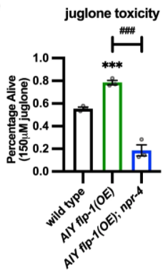
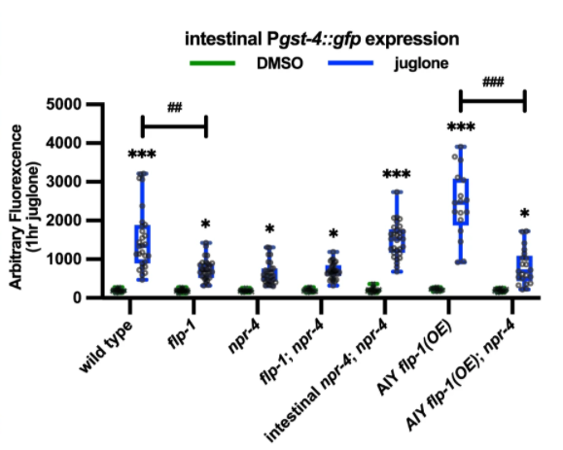

Slide 23: Revisit these questions
- Understand WHY you’re reading the paper. What are some reasons you would read a scientific research article?

- Am I spending too much time on unimportant bits? What would be unimportant?

- Are there terms tripping me up? What would you google?
- Is there another article I can read first? Where would you find this?

- Is there someone I can talk to about this? Who could that be?

Slide 24: Keep asking questions:

Slide 25: Final questions

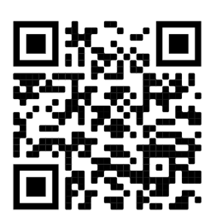
Please fill out this anonymous feedback form to help me make this presentation better for future students!

https://forms.gle/iv8DSeHaSBE78bNq9

